TECHNICAL TEST: Internet allowed
Let's consider the following data model that represents a very small banking application:
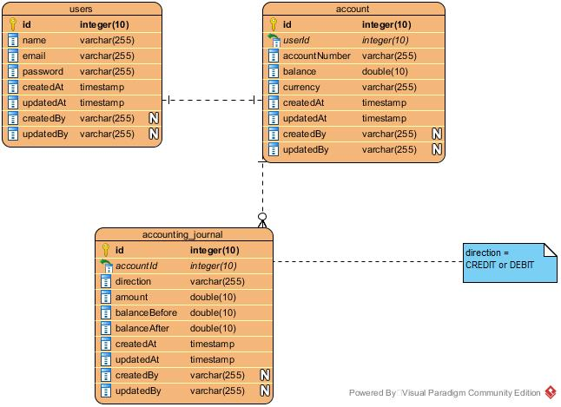
We find there three (03) important entities, namely:
- Users : Represents the system's user table
- Account: Represents the table of client/user accounts in the system
- Accounting Journal: Displays the system's account log.

We would like to develop a small Flutter application that will manage such a banking system.
- Use the following endpoints:
  - POST /api/register: to create an account (unsecured road)
  - POST /api/login: to log in (unsecured road)
  - GET /api/logout [header -> authorization: Bearer TOKEN]: to log out (secured road)
  - GET /api/user [header -> authorization: Bearer TOKEN]: to retrieve the details of the logged-in user (secured road)
  - POST /api/account/credit [header -> authorization: Bearer TOKEN]: to credit a user's account (secured road)
  - POST /api/account/debit [header -> authorization: Bearer TOKEN]: to debit a user's account (secured road)
- Implement the business logic based on the various endpoints mentioned above.

Good luck everyone.

